Adding an ASL Interpreter in Zoom
  - September 2022 update

For Instructors/Meeting Hosts
- When scheduling your Zoom meeting, make sure the Meeting ID is set to Generate Automatically. Then click on the “Select Sign Language Interpretation Channel” option. It is important to select this option ahead of time, as it is not possible to turn on the interpretation channel after the meeting has begun.
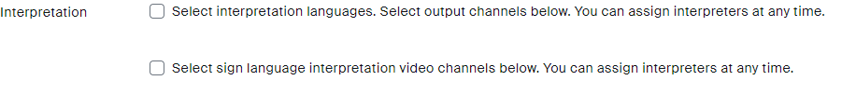
- If you know the assigned interpreters’ names, you can add them now. Otherwise, you can add them when starting the meeting.
- When the meeting has begun, click on the Interpretation Icon on the dashboard.
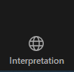
- Now you can add interpreters if you have not yet done so. Click on the “Add Interpreter” button. Note: Interpreters must have already joined the meeting to be added. Disability Services will be responsible for scheduling interpreters for classes, events, and meetings when services are requested. Interpreters will be instructed to join 10 minutes before the meeting is scheduled to start. If you have set up a waiting room, you will need to let them into the meeting.
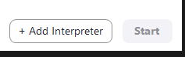
- Start typing ASL Interpreter in the search bar, and a list of participants who have joined the meeting will populate.
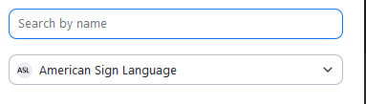
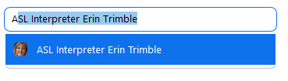
- If there is a team of interpreters for your meeting, click on “Add Interpreter” again and select the second interpreter following steps 4 and 5 from above.
- Once interpreters have been assigned to the interpretation channel, you can click on the blue “Start Now” button.
- Now click on the Participants button

- In the list of participants, hover over the interpreters’ names and click on “Allow to Talk”. This must be enabled for interpreters to voice interpret for a Deaf participant.
- Note #1: The interpretation channel does not work in Breakout Rooms. However, because there are generally less participants in a Breakout Room, the interpreter will still be visible as a general participant. It is important to make sure the interpreter and Deaf student are assigned to the same Breakout Room.
- Note #2: The recordings will NOT include the interpretation channel video.

For Deaf Meeting Participants
- Once you have joined the Zoom meeting, click on the Interpretation button on the bottom.
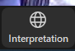
Note: this will only work on a computer—it will not work on a mobile device like a phone or tablet.
- Click on the American Sign Language button
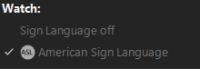
- A new window will pop up with the interpreter visible
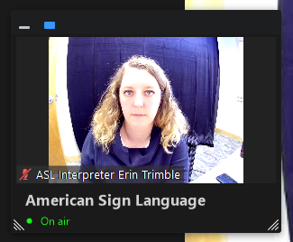
You can resize this window to be as large as you want, and you can move it around to the best place on your screen. This window will always be in view, even when someone is screen sharing. When the interpreters switch turns, the first interpreter will tell you they are switching and then will turn their camera off. The second interpreter’s video will replace the first interpreter’s video.
Note: If the instructor is recording the meeting, the recording will not include the interpreter. If you want a recording with the interpreter included, you need to make your own screen capture recording.

For ASL Interpreters
- Change your participant name to “ASL Interpreter Name” so that the meeting host can quickly find you and add you to the interpretation channel. Please join the meeting 10 minutes early so that the instructor/meeting host can add you to the channel before the meeting starts.
- Make sure your video is turned on.
- Once the meeting host has enabled the Interpretation Channel, and assigned the interpreters to their roles, the interpreter in the Interpreter #1 spot (as assigned by the meeting host) will be the first interpreter to appear in the pop out window when someone clicks on the Interpretation Channel button.
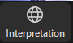
- Click on that Interpretation Channel button and the pop out window will appear with the first interpreter. If you are the first interpreter, make sure the green “On Air” words appear below your video. At this point, the second interpreter turns their video off.
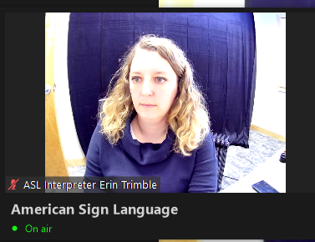
- Hover over the top of the pop out window and select the third button with two bars. This will allow you to see when your team interpreter turns on their camera to make the switch.
- It will also be helpful to make sure the meeting host has enabled you to speak before the meeting has started so that you can voice for the student, if needed.
- The second interpreter should keep their camera off until they are ready to switch. When it is time, the second interpreter will turn on their camera and the first interpreter will see them added to the pop out window. The first interpreter will indicate the interpreter switch and then turn off their camera. The second interpreter will now be visible in the pop out window and should see the green “On Air” message.
Note: Interpreters will not be able to directly message each other in Zoom unless the meeting host has given them co-host privileges.

For All Other Meeting Participants
- The Interpretation Channel will not be visible to the other meeting participants unless they turn it on. If they do so, and want to turn it off, they need to click on the Interpretation Channel button again, and select “Sign Language Off”

