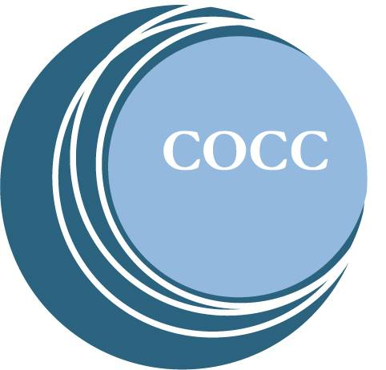

DEPARTMENT and PROGRAM REVIEW FEEDBACK: DEPARTMENT REPORT

COCC’s Department and Program Review (DPR) process is a tool to guide departmental work for three to five years. It includes both a plan and annual report. Department directors submit their reports annually to their dean/VP, on a date that best aligns with availability of assessment data. Once the dean or VP has approved the plan, it should be forwarded to Alicia Moore to include on the DPR website.

Part 5: Data Findings

For the data findings section, directors simply report out the data in a format that is most meaningful for them – tables, charts, dashboard links, narrative or other format. It is important to note that some goals may not have data available annually or that enough time has passed to assess progress on that goal. In that case, directors should indicate when they plan to report on that goal.

Dean/VP Comments:

Part 6: Data Interpretation

While Section 5 reports the data, section 6 is used interpret the data and identify key findings. Examples of information to include identifying internal or external factors that influenced the data, identifying future data needs, evaluating the data to ensure it is relevant to the goal and related findings.

Dean/VP Comments:

Part 7: Action Plan

While Section 5 reports the data and section 6 interprets the data, section 7 creates the action plan going forward based on the data. Some questions to help guide writing this section are:

- If the target is not met, what changes are needed to help reach it?
- Are there significant findings worth celebrating?
- Did the data give information on what you thought it might, or does the assessment method need to change?

Dean/VP Comments:

