DEPARTMENT NAME
DEPARTMENT and PROGRAM REVIEW: DEPARTMENT PLAN

COCC’s Department and Program Review Plan is a tool to guide departmental work for three to five years. It includes the department mission statement and its connection to the strategic plan, goals or outcomes and related activities and how you plan to measure progress towards your goals or outcomes.

Part 1: Department Mission Statement

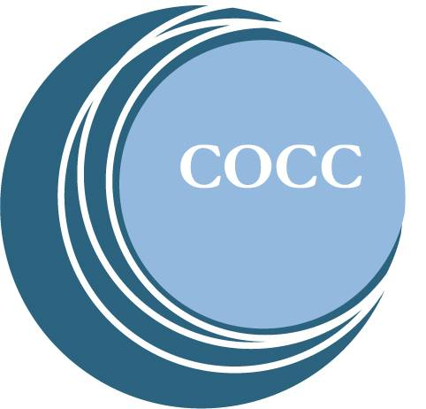
Include department mission statement here.

Part 2: Strategic Plan Connection

COCC’s Strategic Plan includes five goals. Select one to three goals that most closely align with the strategic plan goals:

- Student-Ready College
- Access
- Community Engagement
- Workforce Development
- College Sustainability

Part 3 and 4: Goals/Outcomes and Activities

List up to five department goals, noting that goals are typically three to five years in duration, and include the primary activities for each goal.

Definitions for each are:

- A goal describes the output (product or service) a department is planning to achieve through its organized activities.
- An outcome describes the result for or impact on a customer (internal or external), student, or the institution that is a consequence of the work you do. In other words, what is it that you want your constituents to think, know, or do as a result of interacting with you?
- Activities are those action that lead to achievement of goals or outcomes. Activities have a shorter-term focus, typically achievable in one to two years.

Part 5: Measurement Tool and Timeline

List how you will measure your progress towards each of your department goals or outcomes here. Include the specific tool (e.g., survey, Institutional Effectiveness department data, Banner, etc.) and when you will measure it each year.

